MUJTABA SHAHID FAIZI
BSCS-5A
131818
LAB 3 OF OS

TASK 1

#include<stdio.h>
#include<stdlib.h>
void swap_int(int *a,int *b){
int temp;
temp=*a; //swapping by changing the original variables
*a=*b;
*b=temp;
}
main(){
int a=3;
int b=4;
printf("a=%d\n",a);
printf("b=%d\n",b);
swap_int(&a,&b); //passing the pointers
printf("After swap:-\na=%d\n",a);
printf("b=%d\n",b);
}

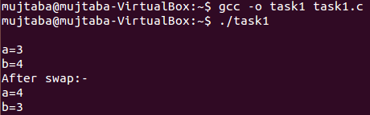

Task2:-

#include<stdio.h>
#include<stdlib.h>
#include<sys/types.h>

main(){
pid_t pid; //processId
pid=fork();
printf("\npid=%d\n",pid);
if (pid==0)
ChildProcess();
else if(pid<0) //negative value indicates childProcess was unsuccessful in creation
printf("Child Process not created\n");
else
ParentProcess();
}

ParentProcess(){
int i;
for (i=0;i<3;i++)
printf("ParentProcess is being run\n");
printf("ParentProcess has ended\n");
}

ChildProcess(){
int i;
for (i=0;i<3;i++)
printf("ChildProcess is being run\n");
printf("ChildProcess has ended\n");
}

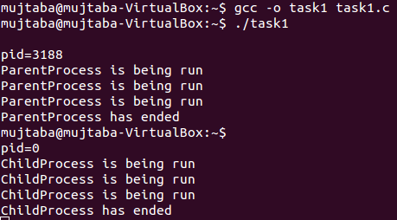

Task3:-

#include<stdio.h>
#include<stdlib.h>
#include<pthread.h>
#include<time.h>

void * thread1_function();
void * thread2_function();
void * thread3_function();
void * thread4_function();

pthread_mutex_t mutex1 = PTHREAD_MUTEX_INITIALIZER;

int arr[100];
int sum;

main(){
sum=0;
srand(time(NULL));
int i;
for(i=0;i<100;i++){
arr[i]=rand()%100;
}

pthread_t thread_id[4];

pthread_create(&thread_id[0],NULL,thread1_function,NULL);
pthread_create(&thread_id[1],NULL,thread2_function,NULL);
pthread_create(&thread_id[2],NULL,thread3_function,NULL);
pthread_create(&thread_id[3],NULL,thread4_function,NULL);

pthread_join(thread_id[0],NULL);
pthread_join(thread_id[1],NULL);
pthread_join(thread_id[2],NULL);
pthread_join(thread_id[3],NULL);

printf("the final sum is : %d\n",sum);

exit(EXIT_SUCCESS);

}
void *thread1_function(){ //4 thread functions with each performing 20% of the work
pthread_mutex_lock(&mutex1); //mutual exclusion lock to block access to "sum" by other threads
printf("Thread number:%ld\n",pthread_self());
int i;
for(i=0;i<25;i++)
sum=sum+arr[i];
printf("the sum is %d\n",sum);
pthread_mutex_unlock(&mutex1); //release the lock
}
void *thread2_function(){
printf("Thread number:%ld\n",pthread_self());
pthread_mutex_lock(&mutex1); //mutual exclusion lock to block access to "sum" by other threads
int i;
for(i=25;i<50;i++)
sum=sum+arr[i];
printf("the sum is %d\n",sum);
pthread_mutex_unlock(&mutex1); //release the lock
}
void *thread3_function(){
printf("Thread number:%ld\n",pthread_self());
pthread_mutex_lock(&mutex1); //mutual exclusion lock to block access to "sum" by other threads
int i;
for(i=50;i<75;i++)
sum=sum+arr[i];
printf("the sum is %d\n",sum);
pthread_mutex_unlock(&mutex1); //release the lock
}
void *thread4_function(){
printf("Thread number:%ld\n",pthread_self());
pthread_mutex_lock(&mutex1); //mutual exclusion lock to block access to "sum" by other threads
int i;
for(i=75;i<100;i++)
sum=sum+arr[i];
printf("the sum is %d\n",sum);
pthread_mutex_unlock(&mutex1); //release the lock
}

